Microsoft account sign in within Azure Environment:

When pulling down a repository from devops, I need to connect to Azure



Clicking on Re-Enter your credentials

Clicking on Continue

Enter in my password

Now have a number

On my phone, I do not get any number

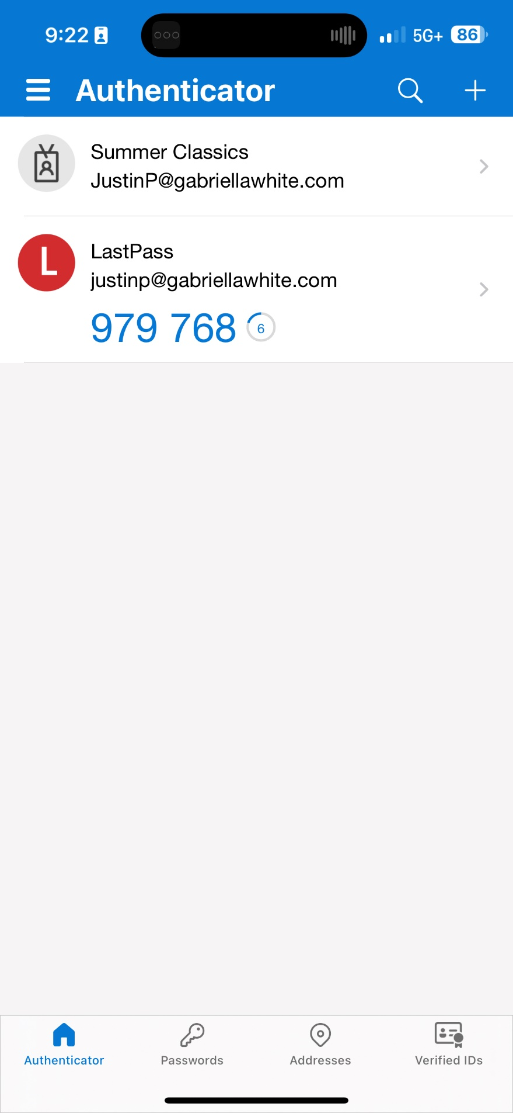

Refreshing the app, results in no new notifications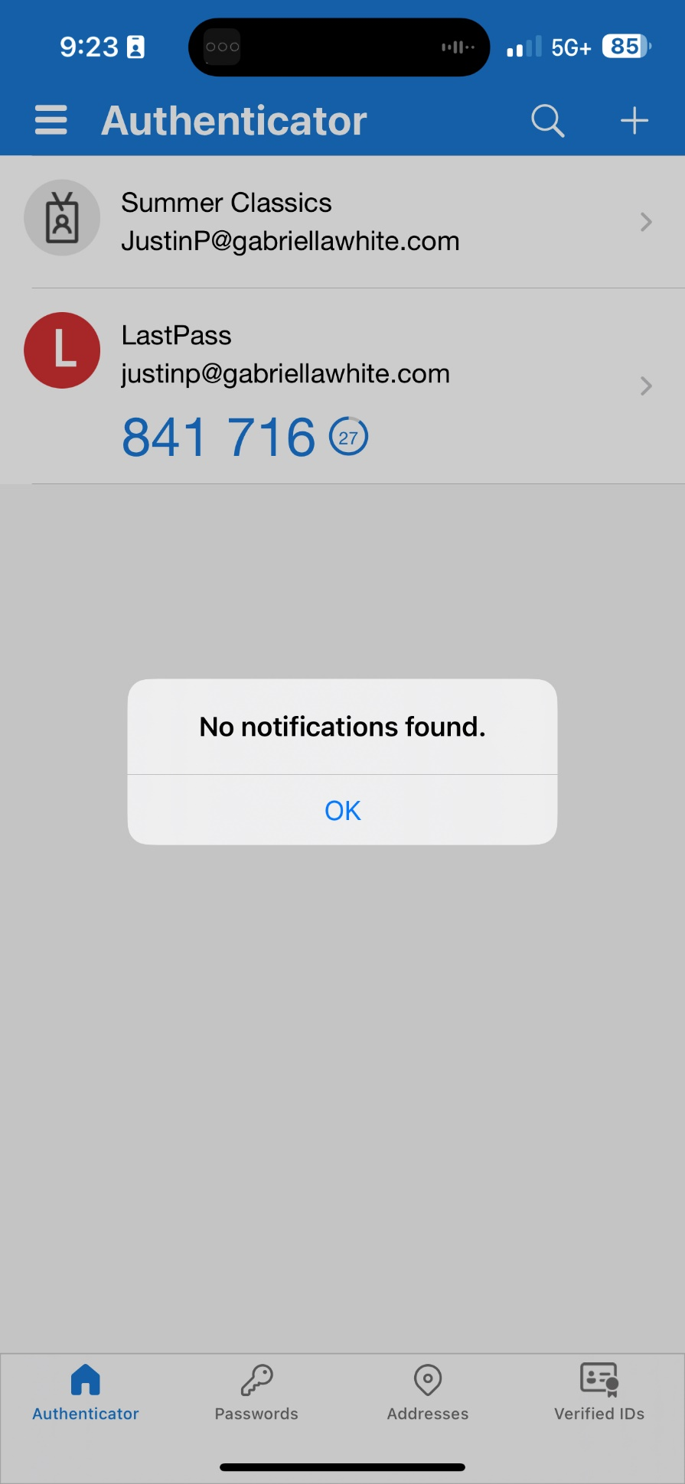

Back in the sign in I click on the blue link

’



Click on Use Authenticator app



I eventually got it to work and notify the Authenticator app and approve the login.

There were a lot of iterations of signing in that would either result in no notification in the authenticator app or show this Script Error.

